**Virtual Key for Your Repositories**

Phase -1 Project

**Project and Developer details :**

The code for this project is hosted at *https://github.com/ManikantaMM/LockedMe.* Project is developed by Mohan Manikanta Murthy.

**Sprint Planning :**

The project is planned to be completed in 3 sprints of 2 days each. Tasks to be completed in the sprint are:

* **Sprint 1:** 
  + Creating the flow chart.
  + Initializing git repo.
* **Sprint 2:**
  + Develop program in Java as per requirements.
  + Test the program for exceptions and breakdowns.
* **Sprint 3:**
  + Push code to GitHub.
  + Documentation.

**Core Concepts :**

The concepts used in the project are:

* File Handling
* Agile framework
* Searching and sorting techniques
* Exception Handling
* Recursion
* Flow Control

**Flow Chart :**

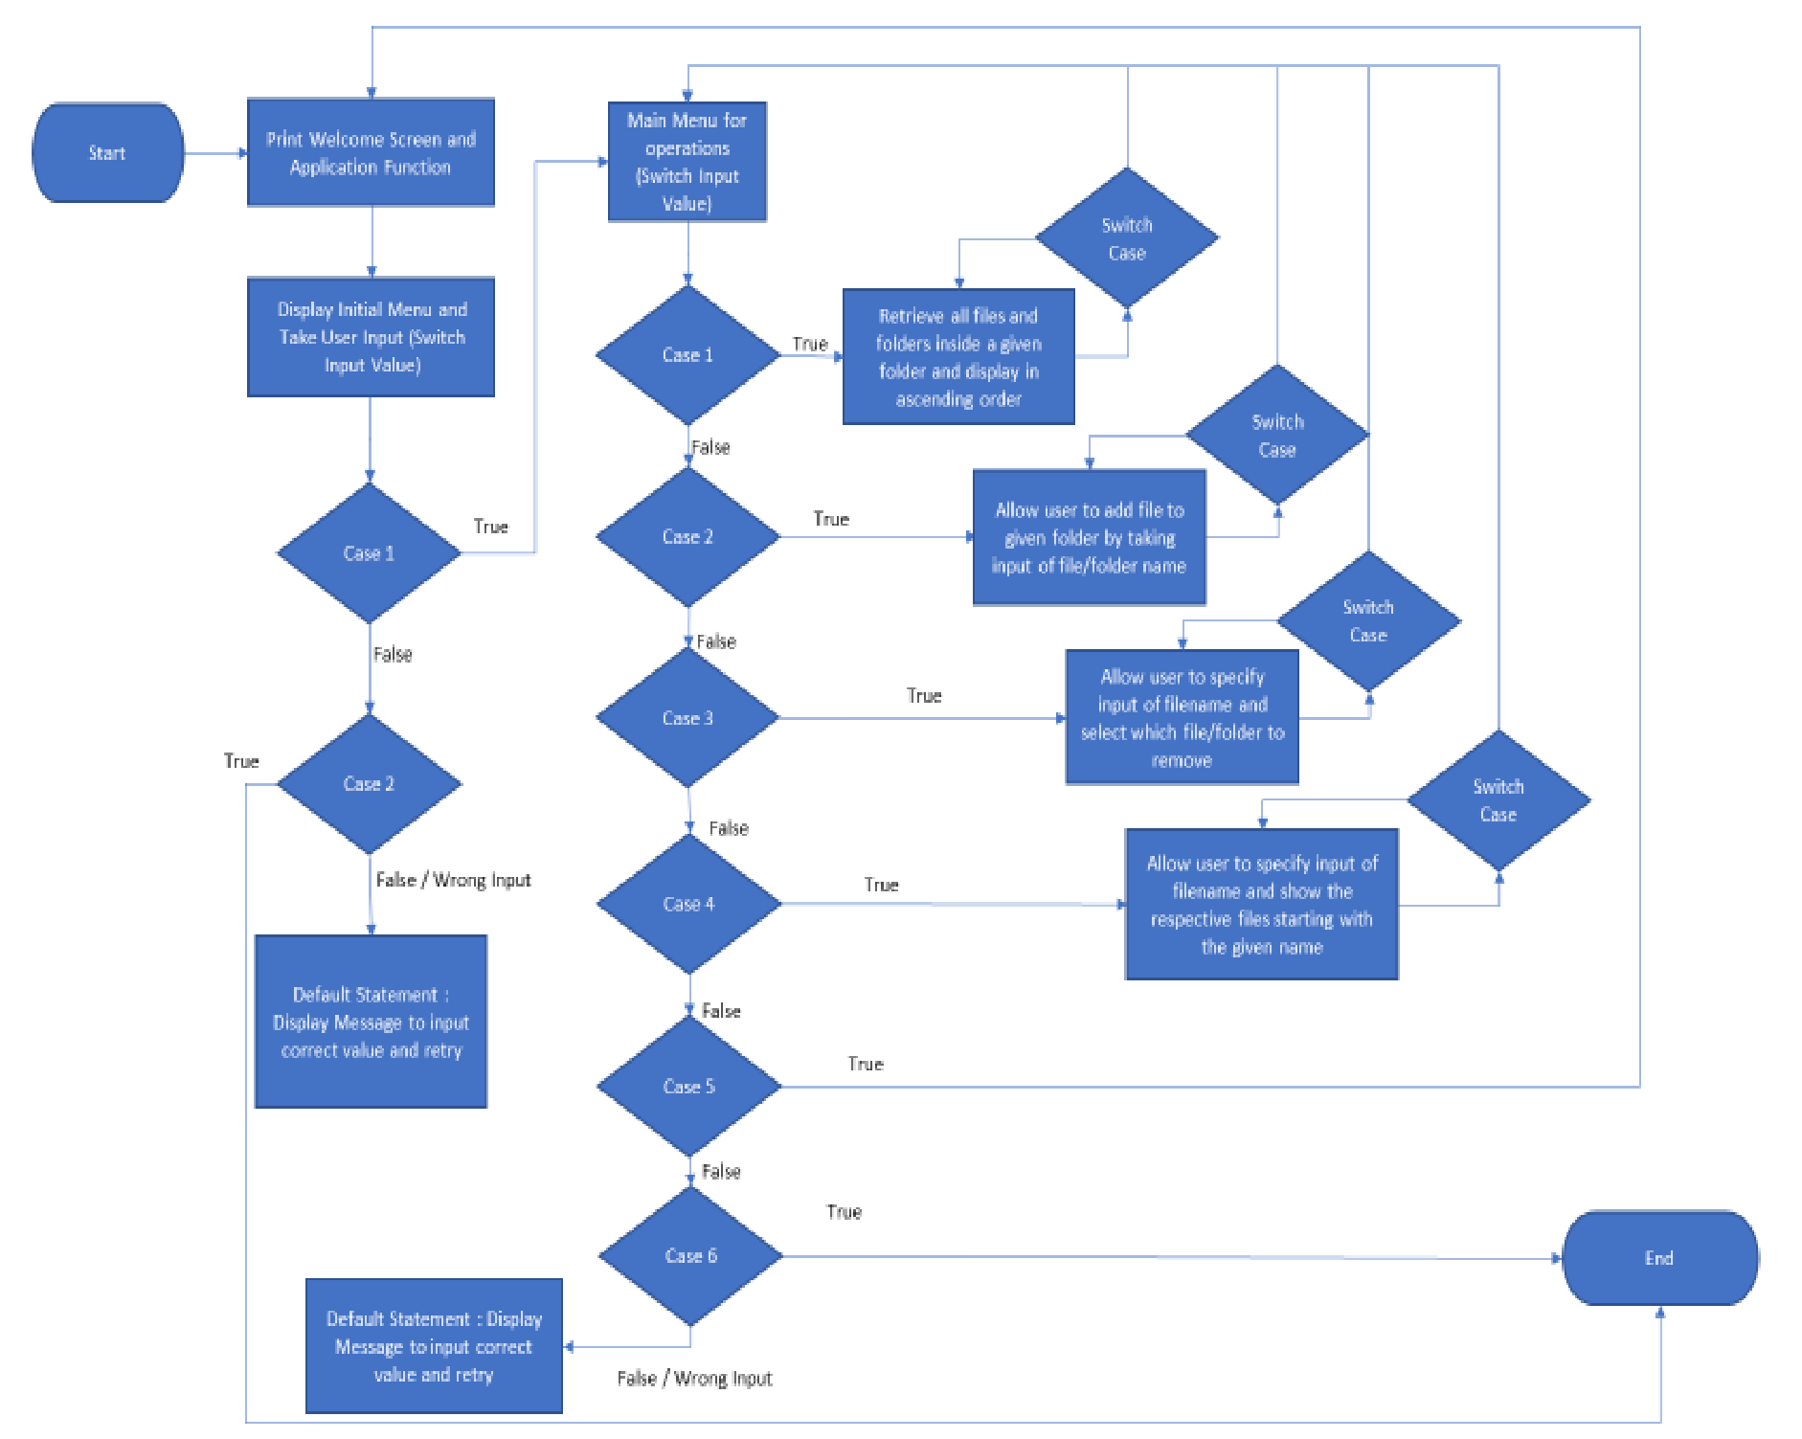

**Step-by-step process :**

1. Creating a new project in Eclipse as LockedMe.
2. Write a program (WAP) in Java for the entry point of the application (App.java) 3. Display Welcome message for the application and include Developer name and Email.
3. Display Main menu for various operations.
4. WAP in Java to Display the Files in a given directory (Ascending.java)
5. Make sure the order of display is Ascending.
6. WAP in Java for File operations such as Add, delete or search (Operations.java)
7. Link the project to GitHub and commit.

**GitHub Repo :**

The code for this project is hosted at *https://github.com/ManikantaMM/LockedMe.*

**USP’s :**

1. The program is able to handle all the exceptions, even if the user enters wrong or invalid input.
2. The program can be terminated upon proper selection of options.
3. The application can be used to perform the CRUD (Create, Read, Update, Delete) file operations.
4. The coding is loosely coupled to support addition of further modules.

**Enhancements** :

* + User Authorization: Conditions to check if user is allowed to delete the file or add the file at the specific locations.
  + Confirmation Step: Asking user to verify if they really want to delete the selected directory if it’s not empty.
  + Modification or addition of data to the files being created or already created.